We are seeking a developer who has strong skills with interactive web pages using HTML, CSS, JavaScript, and JQuery.

Key Requirements:

- JQuery

- HTML

- CSS

We will have a small test that should take one hour to see if the freelancer is capable to handle the work, and we can hire the first one who shows the required result.

Test description:

Design html like the attached image (we don't care about design here, only the script matters), in the left section show some inputs, and in the right section load a web page according to the inputs, and embed an icon according to user choice in the inputs (color, position etc).

We don't pay for the test, but the freelancer that deliver the test we can hire for the project (and that code will be used there).

Skills Required

JavaScript

Website Design

CSS

HTML

jQuery / Prototype

Please complete this test task.

Detailed requirements description is as follows.

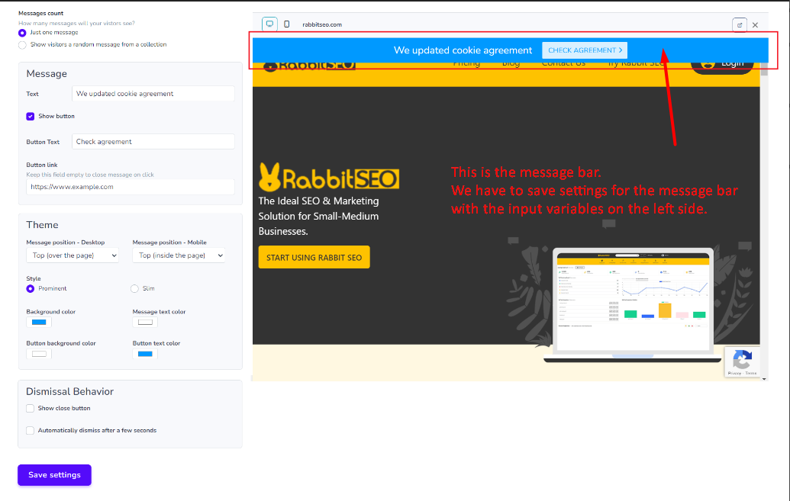

The left side form is for the “Just one message” radio button value.

* Just one message

The Text input is stands for the description in the message bar.

The show button checkbox input shows and displays the next inputs (Button Text / Button Link).

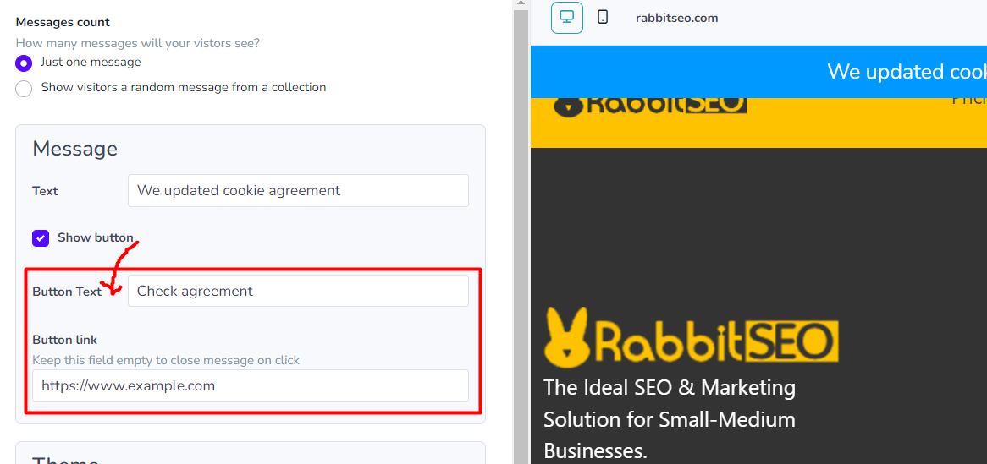

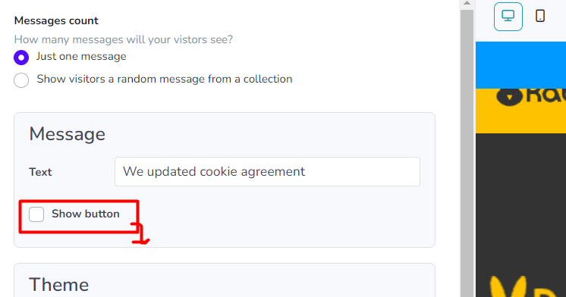

The button Text and Button link input is for Check Agreement button in the message bar.

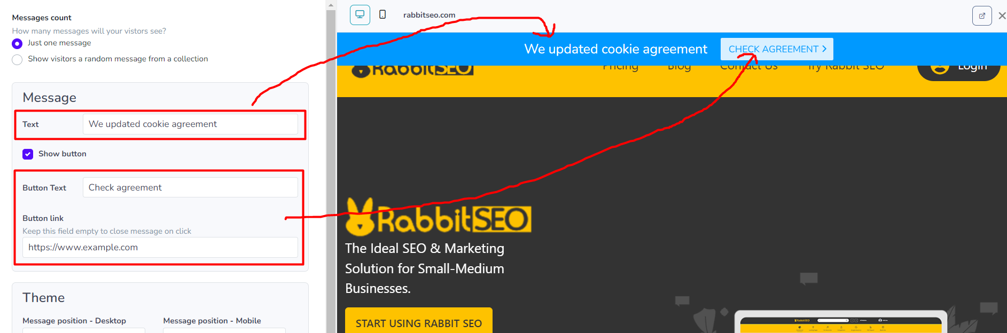

The Theme section is setting for the message bar including color and styles.

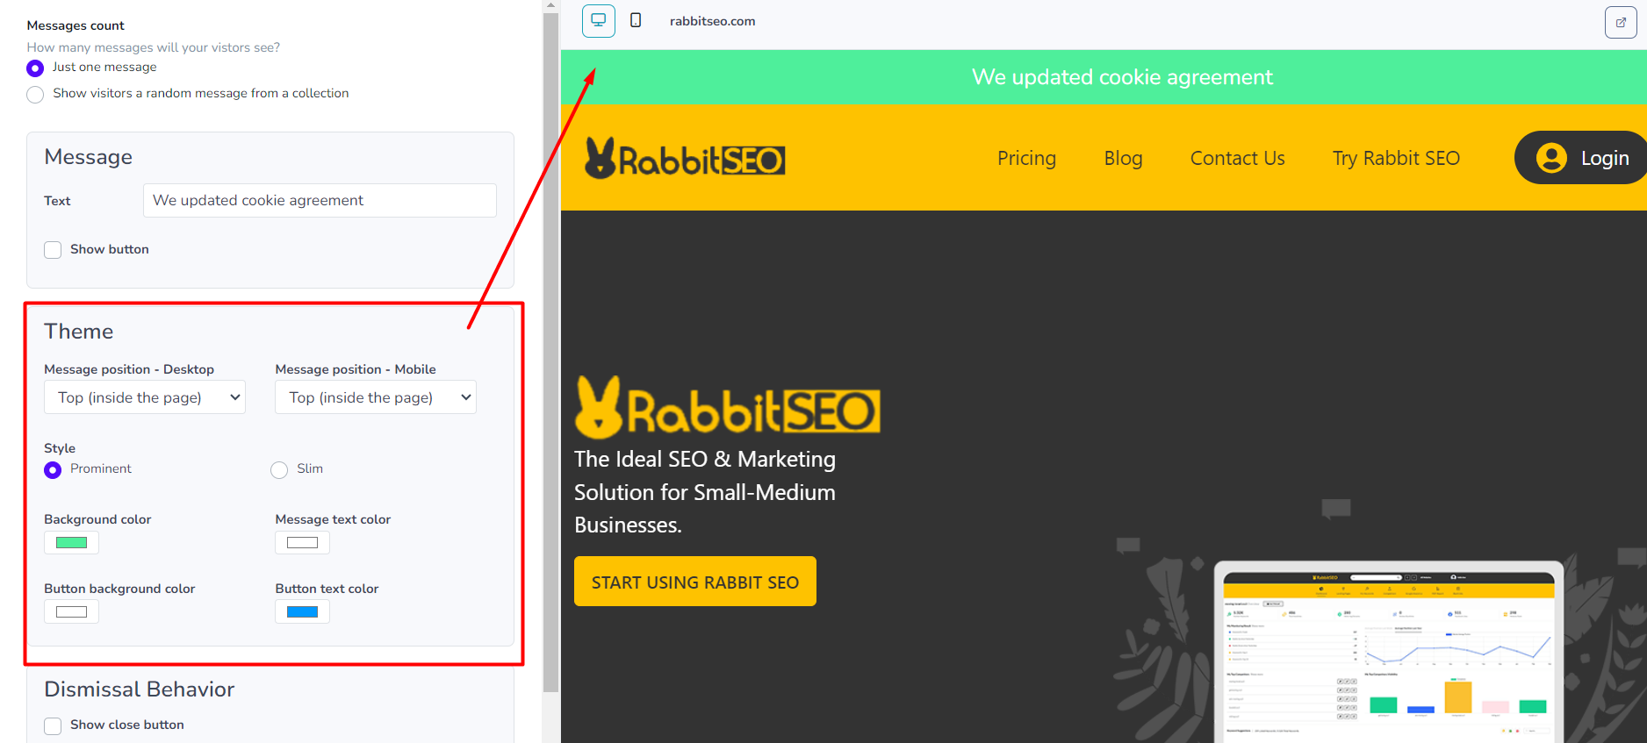

Message Position – Desktop - select box

Available opitons:

Top (inside the page)

Top (over the page)

Bottom (over the page)

Hide on desktop

Message Position – Mobile - select box

Available opitons:

Top (inside the page)

Top (over the page)

Bottom (over the page)

Hide on Mobile

The Background color and message text color is responsible for the background color for the message bar banner and the text color.

Button background color and button text color is for bg and text color for the button.

Dismissal Behavior

The Show close button checkbox input displays and hides close button in right of the message bar.

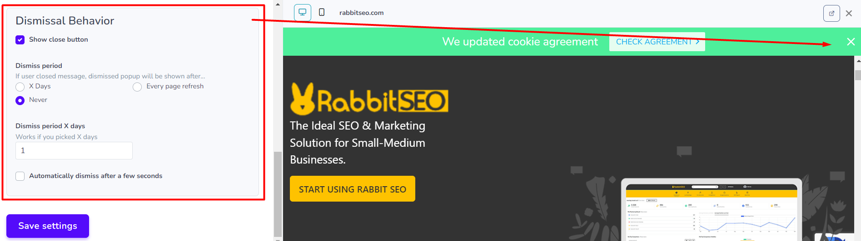

The “Automatically dismiss after a few seconds” checkbox input shows and display the “Hide Delay” input sets the delay time for the message bar.

If we set input number value for “Hide Delay“ input the message bar will disappear after set number of seconds.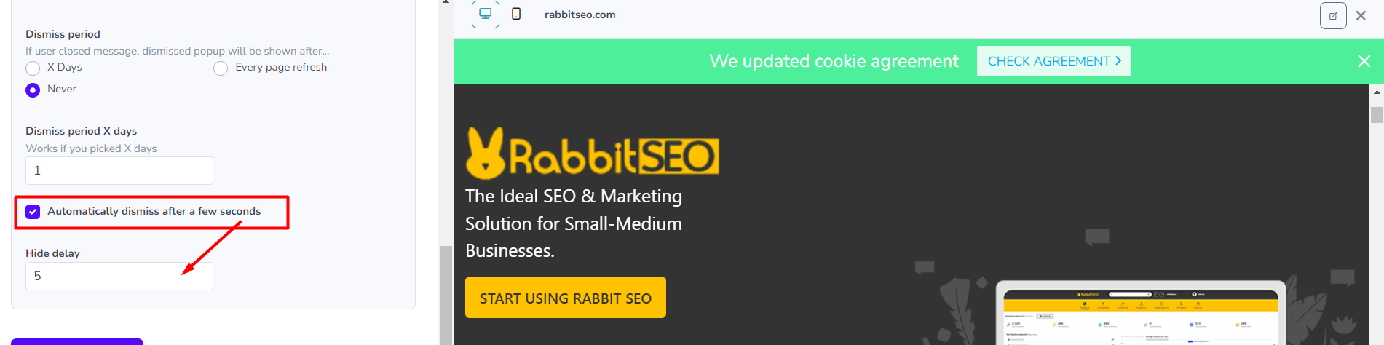

* Show visitors a random message from a collection

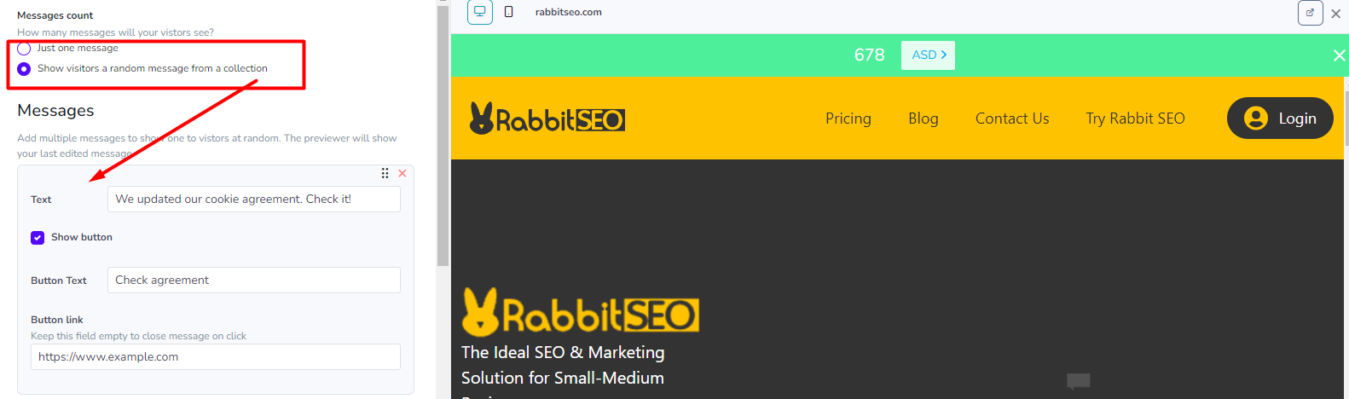

If you select the second radio value (“Show visitors a random message from a collection) there will appear a button “Add item”

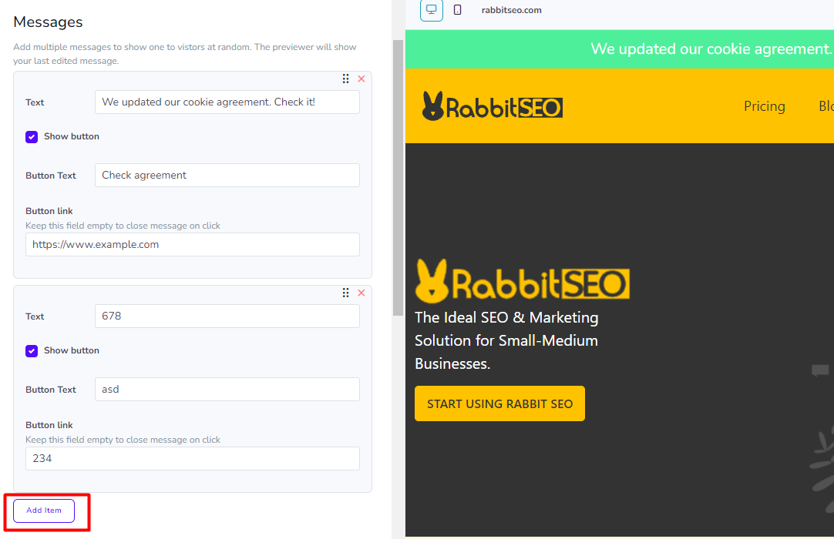

And if I click add item button the form inputs for the Messages section will added to input for another message bar as following img.

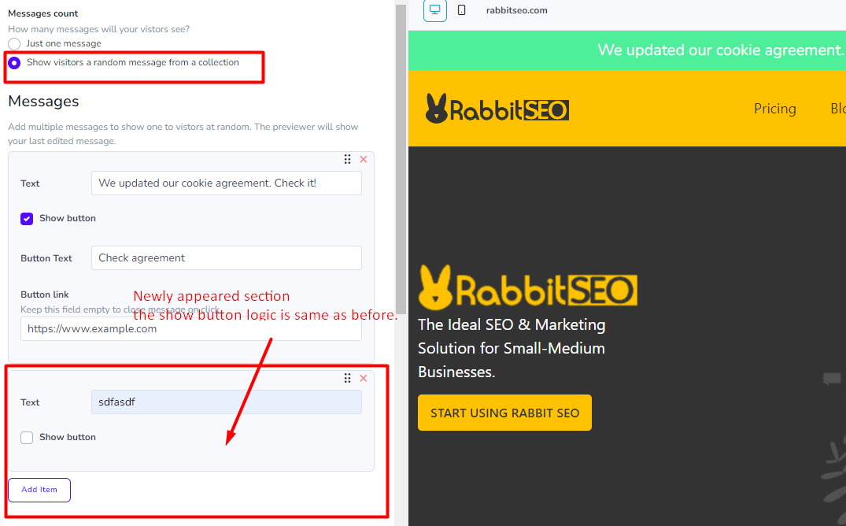

When we click close button in the form inputs, there will be confirmation form like following image.

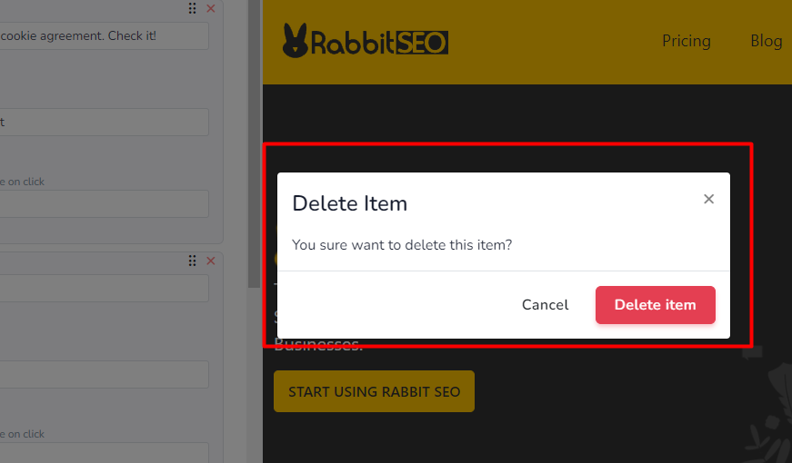

Add some margins for new added components.